**Install Power BI Desktop and share the final screenshot of the report view page which appears when power desktop starts.**

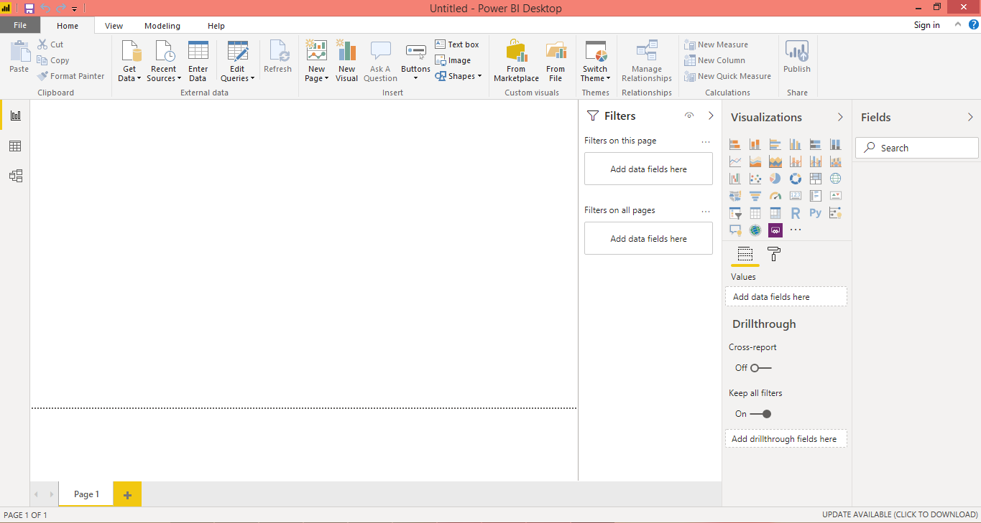

**Prepare a document and with the following screenshot**

**- Report View**



**− Data View**

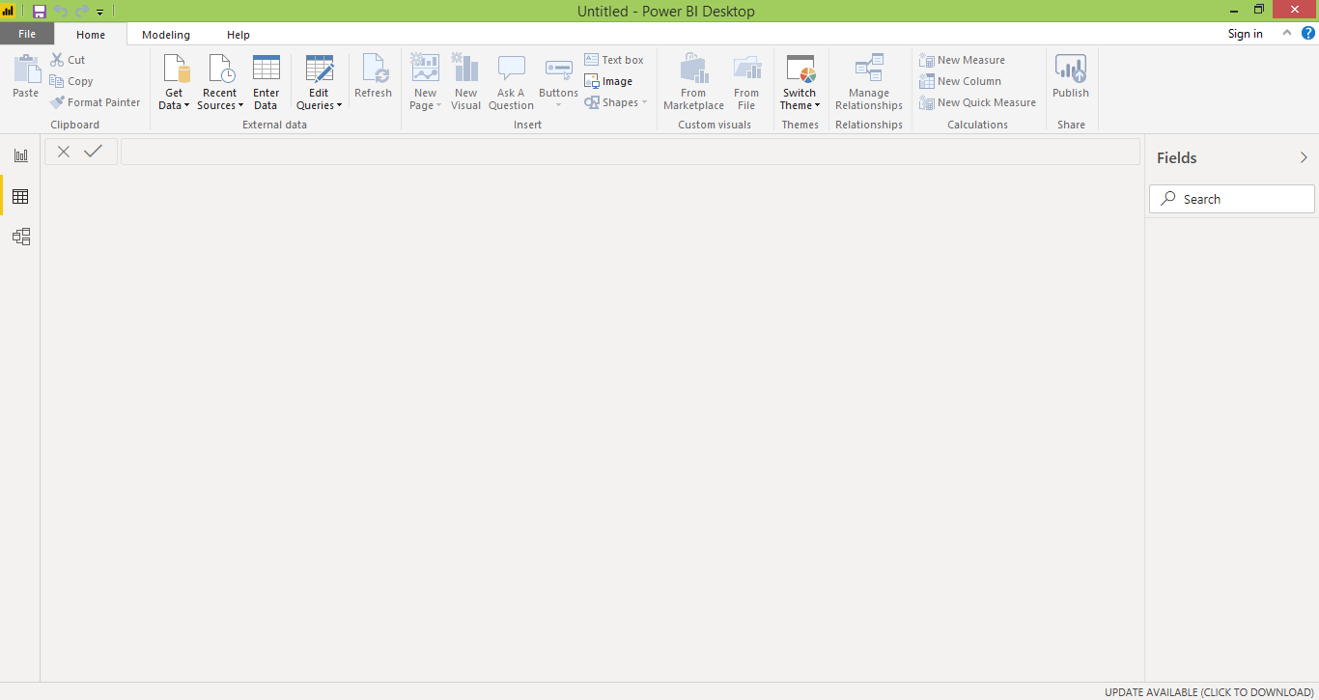

**− Model View**

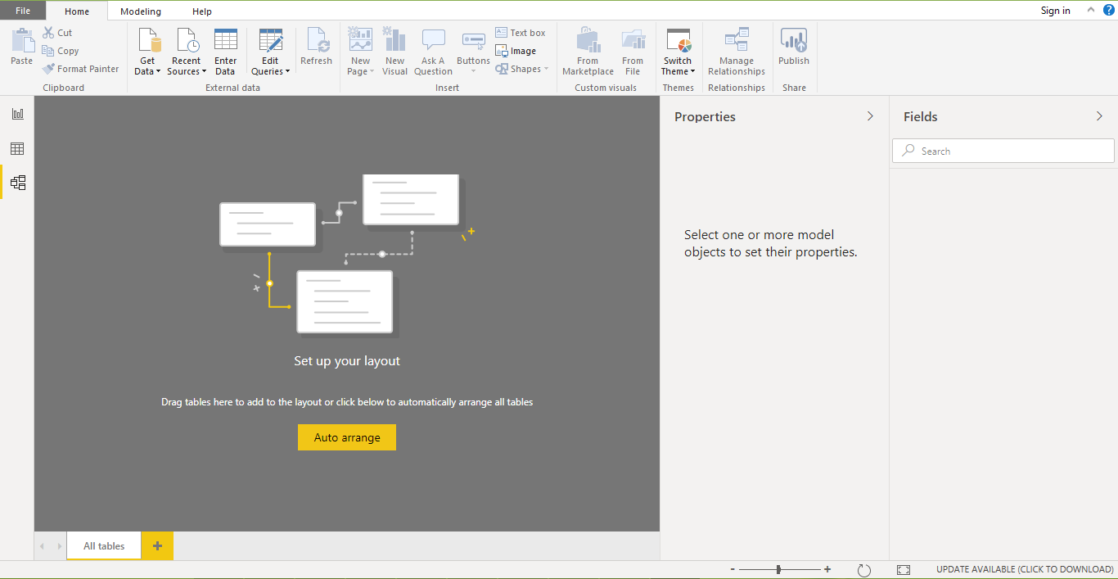

**− Power Query Editor**

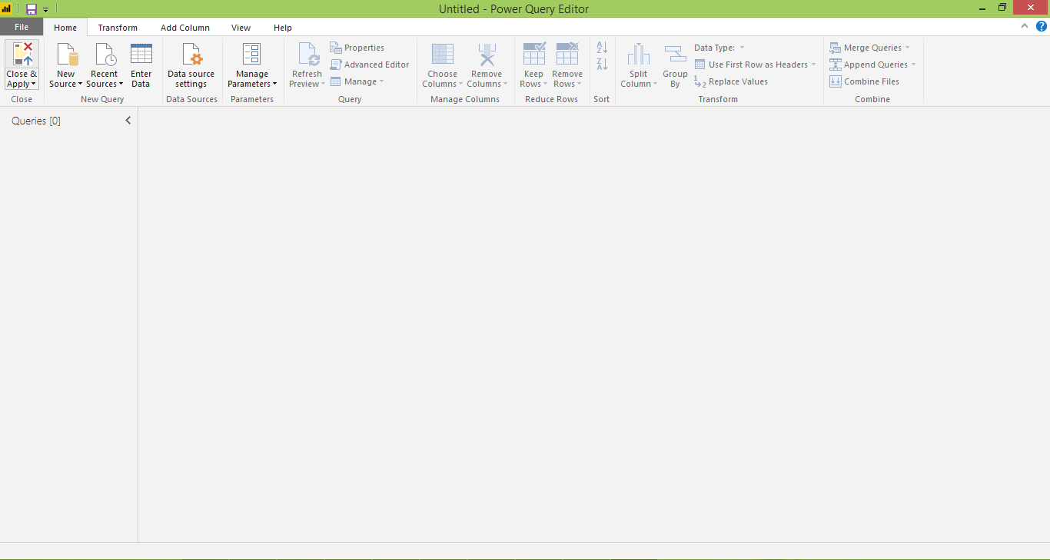

**− Advance Editor**

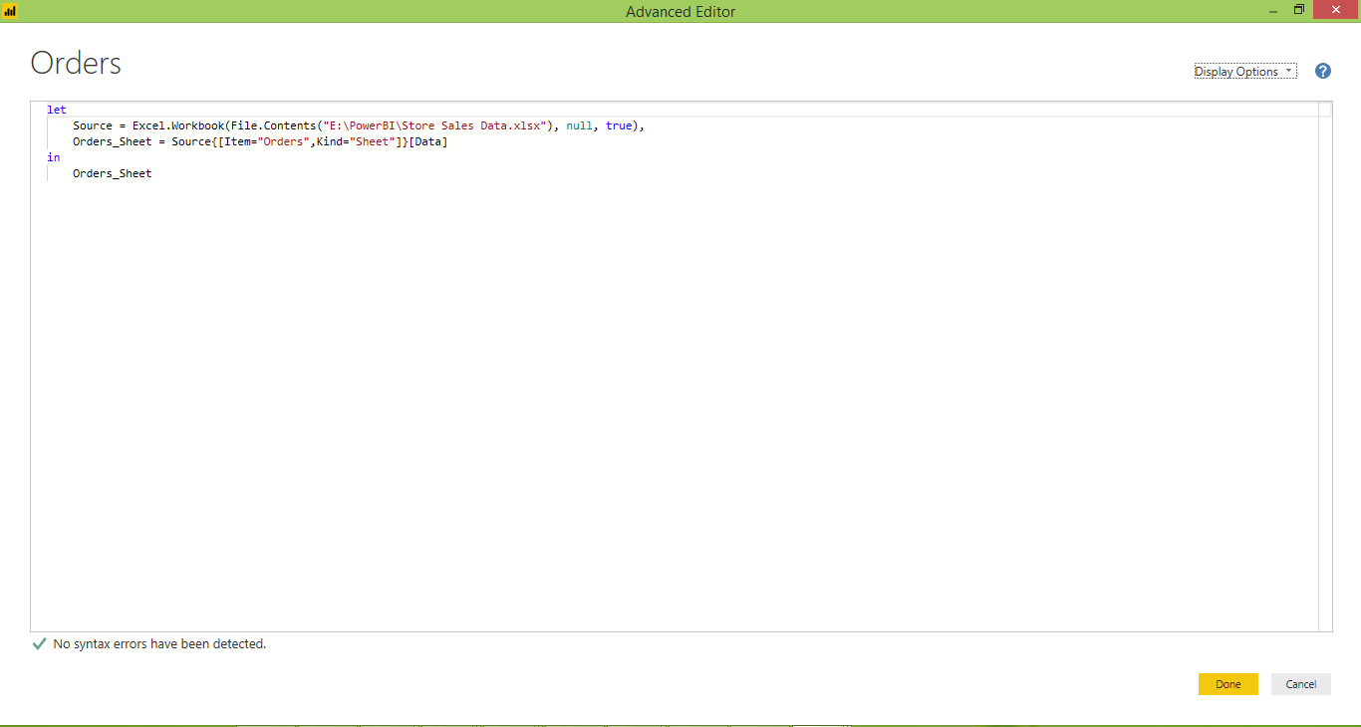

**Prepare a document with details of the following along with their price**

**− Power BI Desktop**

Power BI Desktop is a free application you install on your local computer that lets you connect to, transform, and visualize your data.

The most common uses for Power BI Desktop are as follows:

* Connect to data
* Transform and clean that data, to create a data model
* Create visuals, such as charts or graphs, that provide visual representations of the data
* Create reports that are collections of visuals, on one or more report pages
* Share reports with others by using the Power BI service

Price: Free of cost

**– Power BI Pro**

Power BI Free enables you to connect to 70+ data sources, publish to the web, and export to excel. There are some limitations to the free version. For example, you can’t do peer-to-peer sharing and you can’t create App workspaces. However, the free version is great if you are doing your own analysis and don’t need to distribute the analysis to other end users. You also have connectivity options such as DirectQuery, live connection, and the use of the gateway. The same visualizations that are available in Power BI Pro are available in Power BI Free

Price: The Pro plan costs $9.99/user/month

**–Power BI Premium**

Power BI Premium is a capacity-based offering that includes: Flexibility to publish reports broadly across an enterprise, without requiring recipients to be licensed individually per user. Greater scale and performance than shared capacity in the Power BI service.

Power BI Premium provides dedicated capacity to deliver more consistent performance and support larger data volumes in Power BI. Power BI Premium also enables widespread distribution of content by Pro users without requiring users who view the content to have Power BI Pro licenses.

Price:Premium plan starts at $4,995 a month per dedicated cloud compute and storage resource.